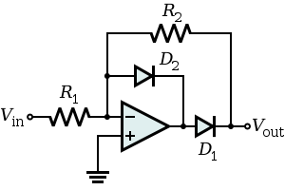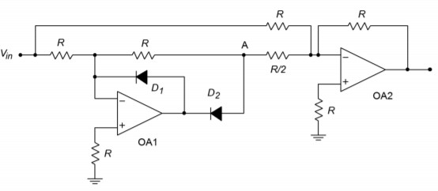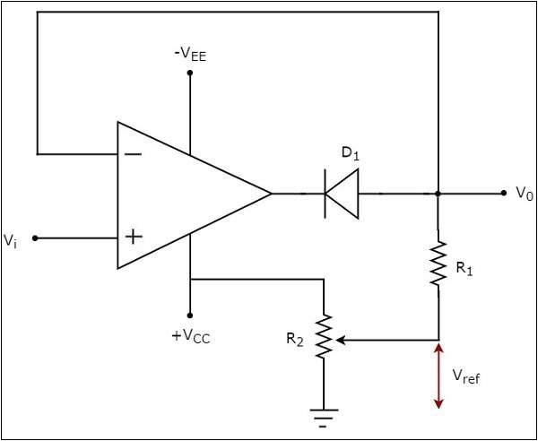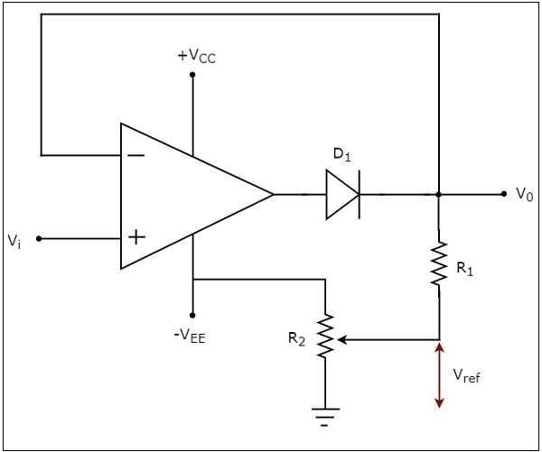

**Topology of the rectifiers and clippers**



**Name – Tapas Mazumdar ID – 2018A8B40427P**

**Analog Electronics Lab #7 – Study the performance of Voltage Rectifiers and Clippers using LM741**

**Objectives**

To study the following rectifiers and clippers using op-amp IC LM741

1. Precision Half Wave Rectifier
2. Precision Full Wave Rectifier
3. Positive Clipper
4. Negative Clipper

and draw output waveforms in each case. Also draw the schematic for each filter.

|  |  |
| --- | --- |
| **Precision Half Wave Rectifier** | **Precision Full Wave Rectifier** |
| **Positive Clipper** | **Negative Clipper** |

**Precision Half-Wave Rectifier**

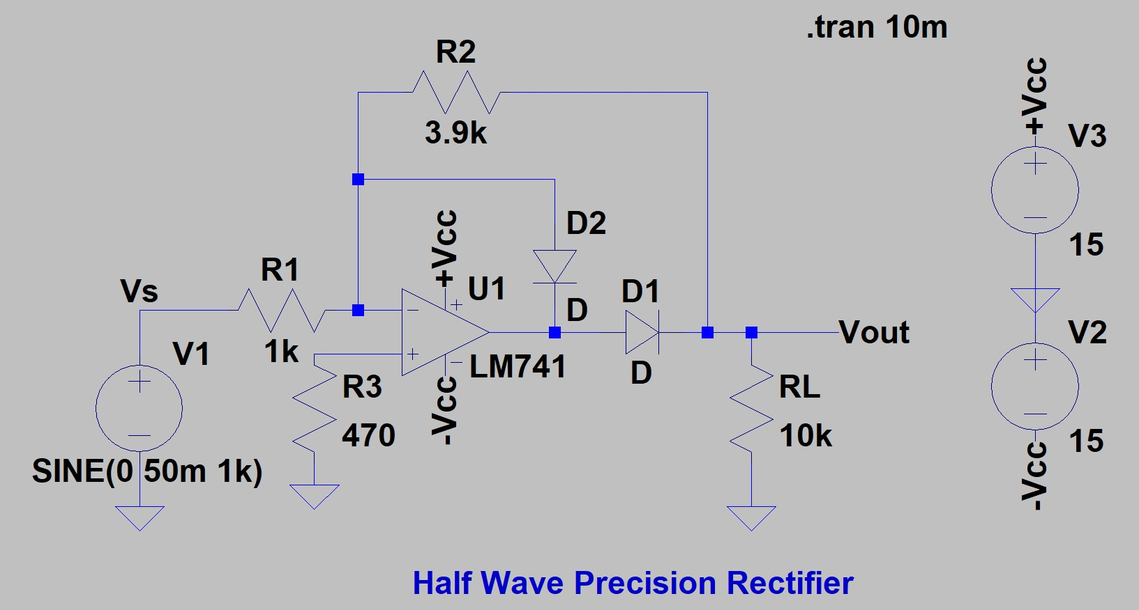

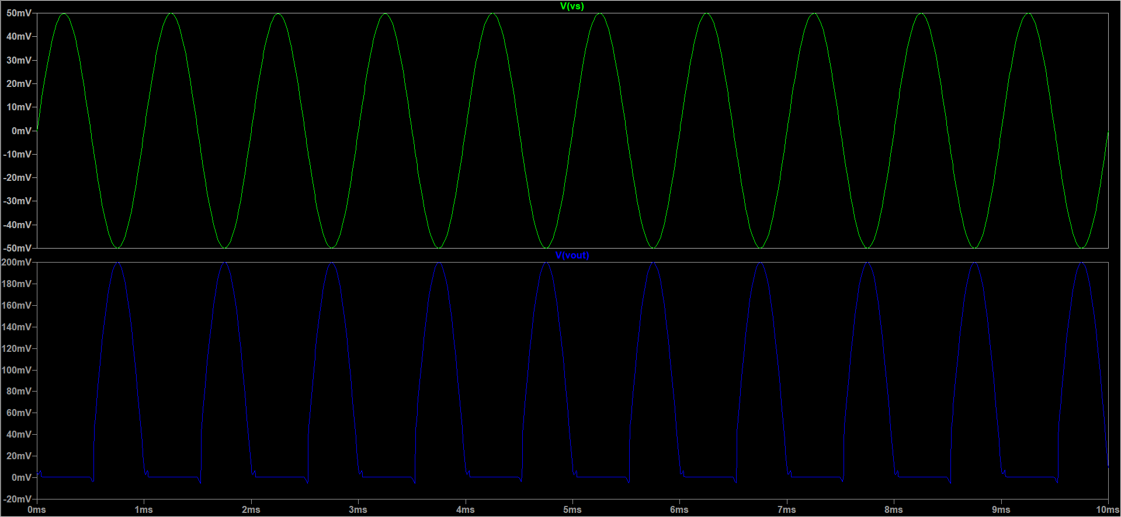

**Precision Full-Wave Rectifier**

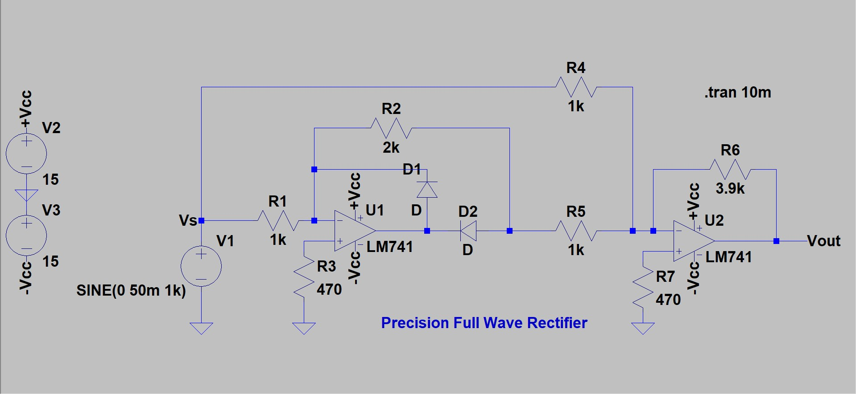

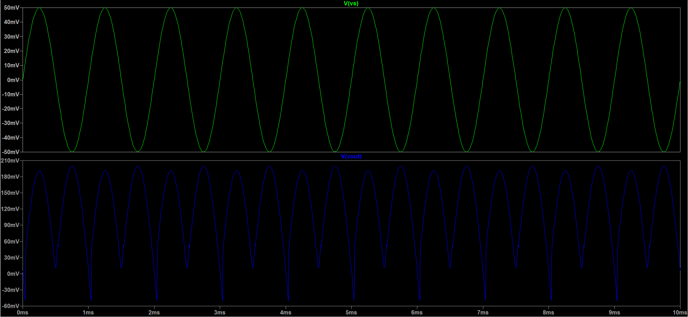

**Positive Clipper**

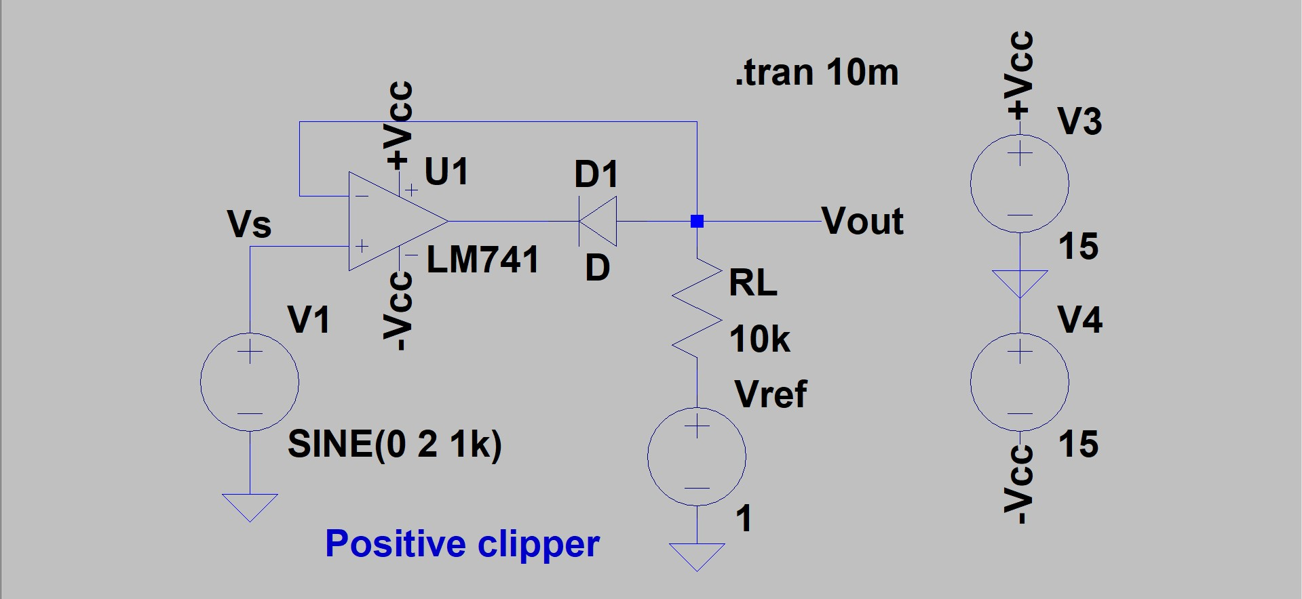

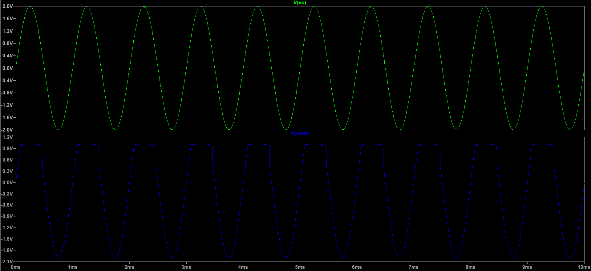

**Negative Clipper**

